**Empathy Map:**

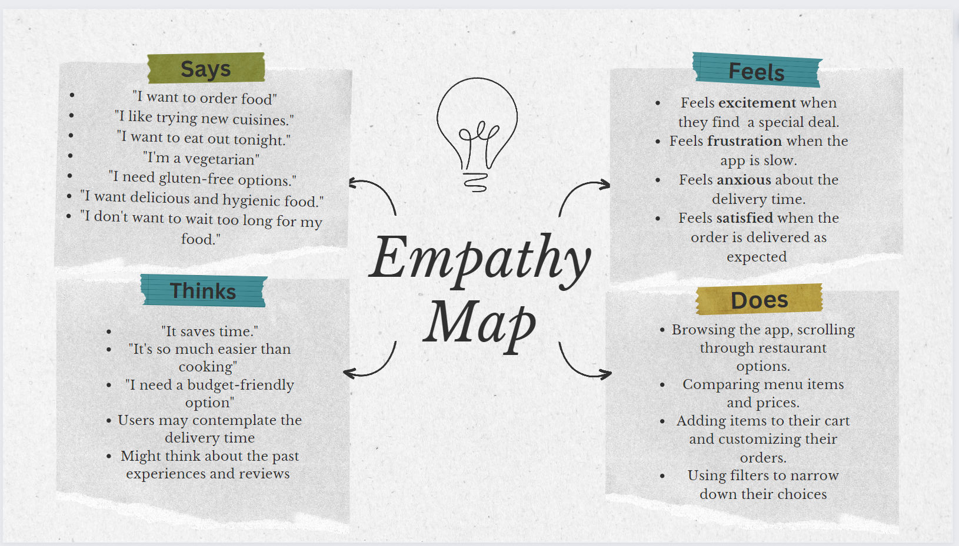

**Brainstorming Ideas:**

* Design a **User-Friendly, lag-free** interface that simplifies the process of browsing restaurants, placing orders, and making payments.
* **Diverse selection of cuisines** from different restaurants, with a specific focus on vegetarian and gluten-free options.
* **Filtering** out the restaurants according to the need of the user
* Provide a robust **user rating system** where user shares their experiences about the restaurant’s food quality
* **Tracking orders in real time** with the contact of the deliverer.
* **Delivering on time** to ensure costumer’s urgency is protected and hunger is rescued.
* **Secure payment** options with **various methods** to pay.
* **Personalize recommendations** for user based on the past order and favourites of the user.
* **Show all discount** available and some eye-catching sales.